UNIT 7 REVIEW GUIDE – Probability
 | Stone Mountain Park | Six Flags Park
Anne |  | $$√$$
Karley | $$√$$
Carson | $$√$$
Debra
James | $$√$$ | $$√$$
Michelle | $$√$$
Brandon |  | $$√$$
Luke
Eddie | $$√$$
Frank | $$√$$ | $$√$$
A teacher asked her students which of them went to Stone Mountain Park and which of them went to Six Flags over the summer break. She created the following chart:

1. Create a Venn diagram for the chart above:
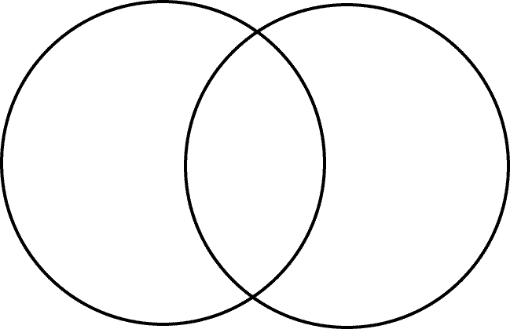
Stone Mt.
Six Flags

2. How many students went to Stone Mountain Ո Six Flags over summer break?
3. How many students went to Stone Mountain U Six Flags over summer break?
4. How many students went to Stone Mountain but did NOT go to Six Flags over summer break?
5. How many students did NOT go to Stone Mountain or Six Flags over summer break?

Given the following Venn diagram, write the subset for each of the following:
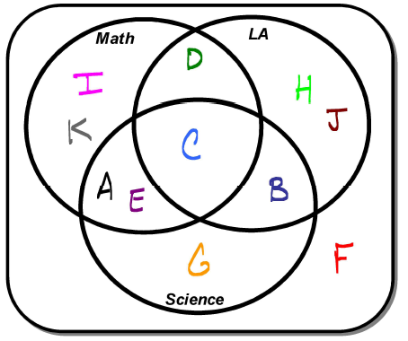
6. (Math)’
7. (LA)
8. (Science U LA)
9. (Math Ո Science’)
10. (LA Ո Math Ո Science)

11. Give an example of theoretical probability.

12. Give an example of empirical probability.

13. Give an example of subjective probability.
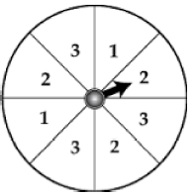
14. What is the probability of spinning the spinner and the arrow landing
on the number “3”?

15. What is the probability of spinning the spinner and the arrow landing
on the number “2” or “3”?
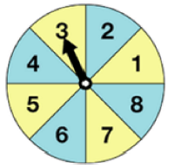
16. What is the probability of spinning the spinner three times and having all
three spins be less than 4?

17. What is the probability of spinning the spinner three times and having all
three spins be greater than 2?

18. A repair person is scheduled to be at your apartment between 10:00am to 12:00pm but you have to leave
at 11:30 to help out a friend. If the repair person is equally likely to be at your apartment any time during
the appointment time, what is the probability that you will be there?

19. A repair person is scheduled to be at your apartment between 8:00am to 12:00pm but you have to leave
at 10:30 to help out a friend. If the repair person is equally likely to be at your apartment any time during
the appointment time, what is the probability that you will be there?

20. Janet has a rectangular back yard with a circular swimming pool. Her yard is 70 feet by 40 feet. Her
swimming pool has a diameter of 16 feet. If your neighbor kicked a ball over the fence and into Janet’s
back yard, what is the probability that the ball lands in the swimming pool?
70 feet
16 feet 40 feet

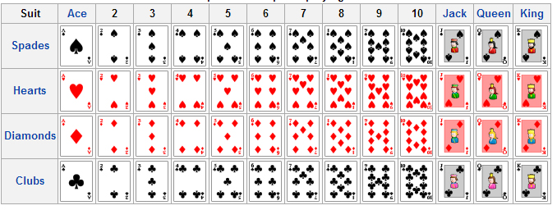
Given a standard deck of shuffled
cards answer the following:

21. Probability of drawing a Club?

22. P(Four | Diamond)
23. P(Five | Black Card)
24. P(Face Card | Spade)
25. P(Diamond U Face Card)
26. P(Face Card U Diamond)
27. A card is randomly drawn from a shuffled deck of cards and NOT REPLACED. A second card is drawn from
the remaining shuffled cards. What is the approximate probability that both cards are Red?

28. In a French class there are 9 male students and 5 female students. A student is randomly selected to go to
the front office and leaves. A second student is randomly selcted to go to the office. What is the
approximate probabilty that both students that left were male students?

29. A jar contains 5 red marbles, 3 blue marbles, and 7 green marbles. What is the probability of pulling a red
marble and then a blue marble (without replacement)?

30. A jar contains 5 red marbles, 3 blue marbles, and 7 green marbles. What is the probability of pulling a red
marble and then a blue marble and then a green marble (with replacement)?

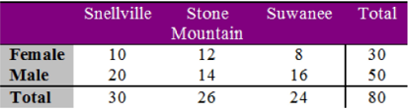
Given the following table with information about
a sample of students from Phoenix High School
and where they live, if a person is randomly
selected determine the probability of the following:
31. P(Female | Stone Mountain)
32. P(Male | Suwanee)
33. Given the P(B) = 0.6 and the P(A|B) = 0.2, determine the P(A and B). $P(A | B) =\frac{P\left(A and B\right)}{P\left(B\right)}$

34. Given P(A) = 0.2 and P(B) = 0.5, determine the P(A or B) if the two events are mutually inclusive.

35. Given P(A) = 0.2 and P(B) = 0.5 and P(A and B) = 0.1 determine the P(A or B) if the two events are inclusive.

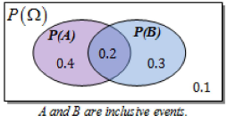
Use the Venn Diagram to answer the following:
36. P(A U B)
37. P(A U B’)
38. P(A Ո B)
Use the following table to answer the following questions:
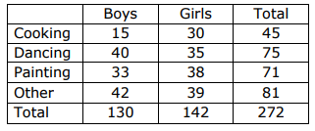

39. What percentage of all students joined the Cooking class?

40. What percentage of boys joined the Cooking class?

41. What percentage of girls joined the Cooking class?

